# 

**IS301: Enterprise Integration**

**Assignment 2  
Walkthrough**

by

Tay Wen Bin

Leow Chun Tat

Gabriel Lok

Ong Zhen Guang

Yong Qian Hwee

Adrian Lee

Group 5, Team 3

for

Professor Venky

Instructor ONG Hong Seng

T2 AY 11-12

TABLE OF CONTENT

A. Form Submission................................................................................... 3

B. Integration Middleware Main Process …………………………………… 4

C. Focus On URA Scenario ………………………………..………………… 6

D. Sub Process - Offence Process ……………………...…………………... 7

E. Sub Process - Payment Process………………………………………….. 8

F. Sub Process - Reply Process ………….………………………..………… 8

G. Summon Summary ……...………………………...……………..………… 9

H. Appendix ……..………………………...……………..……………….……. 10

**Walkthrough**

**A) Form Submission**

1) A parking enforcement officer uses an electronic handheld terminal (EHT) to interface with the Summon Application (SA) to send over the vehicle’s license plate number, the carpark id and the offence type committed, which are inputted into the respective fields of the Summon Form.

|  |  |
| --- | --- |
| Macintosh HD:Users:zhenguang:Dropbox:GUMMY BEARS:ScreenShot:Capture1.JPG | **Fill in** 1) Vehicle License No.: 2) Select Carpark ID: 3) Offence |

Figure 1

2) Once submitted, a processing page will be loaded as shown in figure 2.

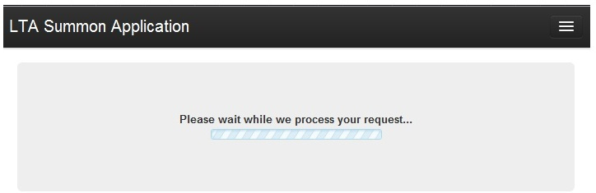

Figure 2

**B) Integration Middleware Main Process**

1) Below is an overview diagram of the **integration middleware**

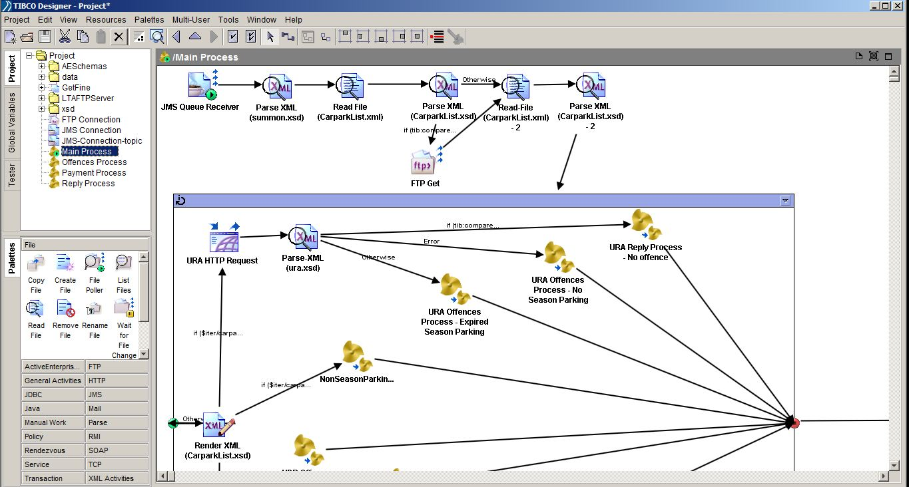

Figure 3

2) There are 4 processes within the **integration middleware** comprising of a single main process and three sub processes.

|  |  |
| --- | --- |
| Macintosh HD:Users:zhenguang:Dropbox:GUMMY BEARS:ScreenShot:Capture0.JPG | **4 Process Definition**  - 1. **Main Process** - 2. Offences Process  - 3. Payment Process - 4. Reply Process |

Figure 4

3) The **Summon Application** will then route the relevant details like the vehicle license plate number, carpark id and offence type to the **integration middleware** in the **LTA** via a JMS queue using a request-reply pattern. The integration middleware will receive the JMS message and extract the body of the message, which is then translated into DOM by the Parse XML. (**Figure 5**)

The **integration middleware** will check through the validity period of the cached list of carparks (CarparkList.xml). (**Figure 6**) In the event the validity period of the cached list of the carparks has expired, a “FTP get” will be invoked, retrieving a copy of the updated list of carparks from the **CarPark Management System**. This whole process is depicted in **Figure 5**.

Caching is enabled in the integration middleware because There maybe countless of potential summon tickets sent in a day. Hence caching will help to prevent the wastage of resources and effectively reduces processing time.

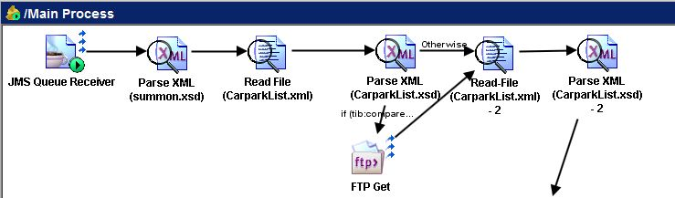

Figure 5: illustration of caching

|  |
| --- |
| Macintosh HD:Users:zhenguang:Dropbox:GUMMY BEARS:ScreenShot:carlistXML copy copy.jpg |

Figure 6: CarparkList.xml

4) Upon receiving the latest CarparkList.xml, the IM will iterate through the carparkList.xml to check for the corresponding company name based on the carpark id given by Parking Enforcement Officer. Currently all carparks in Singapore are either in the charge of HDB or URA. (**Figure 7**)

|  |
| --- |
| Macintosh HD:Users:zhenguang:Dropbox:GUMMY BEARS:ScreenShot:7 copy copy.jpg |

Figure 7

**C) Focus On URA Scenario**

Depending on which company the enquired carpark id corresponds to, the process will be directed by the integration middleware to **either HDB or URA HTTP Request**. This will then invoke the web service (**HDB Season Parking Web Service or URA Season Parking Web Service**). In this scenario, we will be focusing on the process that is directed to **URA HTTP Request (Figure 8).**

1)The function of the **URA HTTP Request** is to invoke the URA Season Parking Web Service. The vehicle license plate number and carpark id are submitted to the URA season parking web service to check if the vehicle has a valid season parking for the carpark registered under URA.

2) The **Parse-XML** will then parse the **ura.xml** (**Appendix Section I Figure 13**) with the relevant information that has been obtained from the URA Season Parking Web Service**.** There are 3 possible outcomes that may result:

2.1) If the enquired vehicle license plate number **has a valid season parking**, then the process will be routed to **URA Reply Process-No Offence**. After which the sub process, **Reply Process, (Section F)** will be executed.

2.2) If the enquired vehicle license plate number **does not have a registered season pass** with URA, the process will be routed to **URA Offence process-No Season Parking**. After which the sub process, **Offences Process** **(Section D)**, will be executed.

2.3) If the enquired vehicle license plate number **has an expired season parking**, which **has not been renewed**, the process will be routed to **URA Offence process-Expired Season Parking**. After which the sub process **Offences Process (Section D)** **will** be executed.

3)In the event that the offence committed is a nonrelated season parking offence, the process will then be routed to **NonSeasonParkingOffences**. After which the sub process, **Offences Process (Section D),** will be executed.

All the steps that are shown above are documented in Figure 8.

|  |
| --- |
| Macintosh HD:Users:zhenguang:Dropbox:GUMMY BEARS:ScreenShot:8-2.jpg |

Figure 8

**D) Sub Process - Offence Process**

This is an overview of the sub process, **Offences Process**. This sub process will occur after parts 2.2 , 2.3 and 3 from section C.

A **JMS message** containing the **enquired vehicle license plate number** will be sent by a **JMS queue Sender via queue** to the COE Application, which is listening to any incoming messages.

1. The **JMS Queue Message** will then wait for the reply from the COE Application. The COE Application will check and retrieve the vehicle owner’s information based on the given the vehicle license plate number. The information will be sent as a JMS message via a queue to the **JMS Queue Message** in **integration middleware**.
2. The **Parse XML** will then parse the **coeinfo.xml** (**Appendix Section II Figure 14**) with the relevant information that is obtained from step 2.
3. The **SOAPRequestReply** will invoke a method in the **TP Offences and Fines web service** (**getFine**) to obtain the fine amount for the corresponding offence. The SOAP based web service will require 2 parameters namely the offence and the vehicle type.

1. Depending on which company the enquired carpark id has formerly corresponded to, the **Render XML** will then render the appropriate information such as the vehicle owner’s name and fine amount into either **urasummon.xml** or **hdbsummon.xml**.
2. The JMS message containing the summon information will be routed to either **HDB or URA** using a **JMS Queue Sender (HDB) or JMS Queue Sender (URA)** respectively. This is content based routing as the summon information is routed to either HDB or URA based on the company identified earlier. After which, the sub process, **Payment Process** **(Section E – figure 10)** will be executed.
3. After the sub process **Payment Process** has been executed, the other sub process, **Reply Process, (Section F - figure 11)**will be executed.

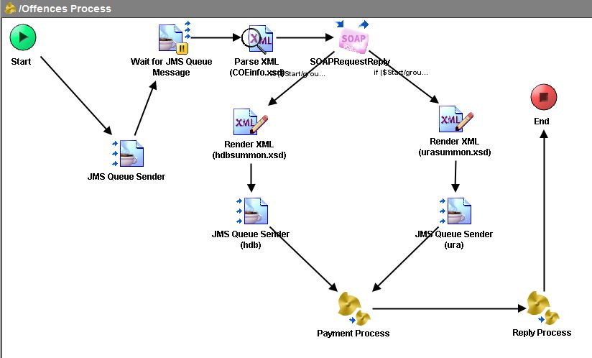

Figure 9

**E) Sub Process - Payment Process**

The **Render XML** in the sub process, **Payment Process** renders relevant information such as the vehicle owner’s name, vehicle owner’s NRIC and the fine information into the **payment.xml**. This will then be sent as a JMS message via a topic to the **Payment Application(PA)** in both the AXS and SAM . The Payment Process overview is illustrated in the figure below (**Figure 10**).

|  |
| --- |
| Macintosh HD:Users:zhenguang:Dropbox:GUMMY BEARS:ScreenShot:10.JPG |

Figure 10

**F) Sub Process - Reply Process**

The Render XML in the sub process, **Reply Process** renders relevant information such as the vehicle owner’s name, vehicle owner’s NRIC and the fine information into the **summon.xml**. This will then be sent as a JMS message via a queue to the **Summon Application**. The Reply Process overview is illustrated in the figure below (**Figure 11**).

|  |
| --- |
| Macintosh HD:Users:zhenguang:Dropbox:GUMMY BEARS:ScreenShot:11.JPG |

Figure 11

**G) Summon Summary**

The parking enforcement officer will then receive the summary of the summon details of the vehicle owner.

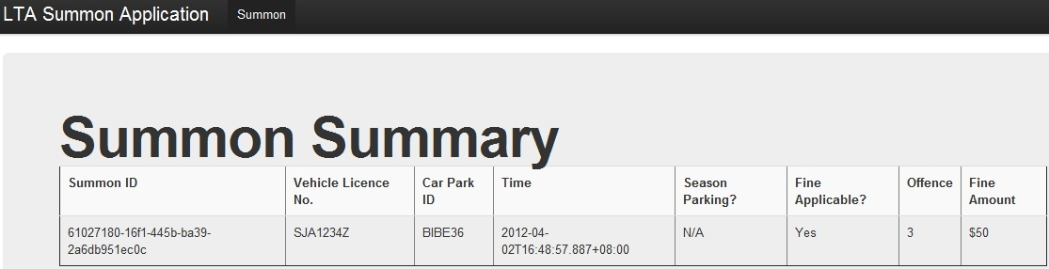

**H) Appendix**

**I) ura.xml**

As shown the figure below, the ura.xml will contain information such as the vehicle license plate number, the owner of the vehicle, the parking id, the location of the car park and the validity of the season parking. The Parse XML will translate the ura.xml to DOM.

|  |
| --- |
| Macintosh HD:Users:zhenguang:Dropbox:GUMMY BEARS:ScreenShot:Screen Shot 2012-04-03 at 1.30.15 PM.png |

Figure 13

**II) coeinfo.xml**

As shown the figure below, the coeinfo.xml will contain information such as the vehicle license plate number, the owner of the vehicle, the owner’s NRIC and the vehicle type. The Parse XML will translate the coeinfo.xml to DOM.

|  |
| --- |
| Macintosh HD:Users:zhenguang:Dropbox:GUMMY BEARS:ScreenShot:Screen Shot 2012-04-02 at 6.04.44 PM.png |

Figure 14